# Game Engine development Prac1

Humberto Carolino ST20158095

**Cloning the repository**

https://github.com/AlphaTears/GameEnginePrac1.git

The repository should be in public so anyone can clone it and see it, inside of it there will be the gameplay video and a clone of this same document without the extra cloning Link.

**Introduction**

In order to be able to complete this project I had to use different game engines, which in this case I implemented ogre3D and bullet Physics into our project so that way we could be able to use their libraries to make a game out of it.The way that we implement these libraries is by giving our visual studio pointer to where each header files should be at and in addition, we also have to add specific dll files into the repository to be able to use ogres and bullets functionalities. In this project multiple different APIs were used in order to be able to achieve the prototype the project goes from simple APIS such as “Setposition()” to harder APIS that require a lot more variables like for example “createRigidBody()”. A lot of the other APIS used will be talked through the document and proof will be shown in the different screenshots used in the document. (CardiffMetrapolitan, n.d.) (Ogre3d, n.d.)

**Display of level Geometry:**

For my game I have two different ways of displaying the graphics and geometry within my game world. The first one being creating a header and CPP file to make multiple functions which would then just be passed on to the setup of your game which runs every function at a time to load the game objects into the game window.

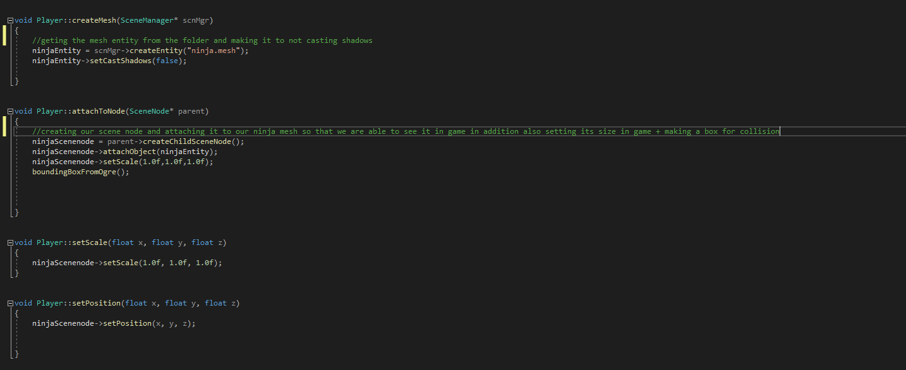

In this first screenshot we can see the way of rendering a mesh into the game window by using a separate class. To do this we are going to need two functions, one which will create the entity and the second one which will create a scene node so that you can attach your entity to it. The entity object will have the 3d object or will attached to it and to be able to access that entity you will need to create a scene node so that you are able to see it in your world. To be able to create an entity we are going to need a scene manager which will take record of every object in your world either it be the map or the player. After we create the entity, we need to attach it to a specific scene Node. And the scene Node will be our object in the world after doing this work we can attach different functions into your entity or scene node as shown in the screenshot, we can set the scale to be bigger or smaller. If the scale is set to 1, 1 ,1 then the size of the node will be the same as it is by default. There are other functions that we can use to move the player around or change its position as an example we can use yaw() to change the rotation of the player however this function only changes 1 rotational axis, if you want to rotate an object in different ways you are going to need to use a rotate() function. Another function that we see in this screenshot is called setCastShadows() and what it does when turned on it will cast shadows in the ground and other objects that could be around it for my game, I decided to turn all of this off as it would look really annoying and bad in my opinion. In addition to all of that we also have a setMaterial() which to be able to do that we need to have a place in our repository where we will be defining the materials that ogre should be able to pick up from our images. To do this he need to give it a path and a name.

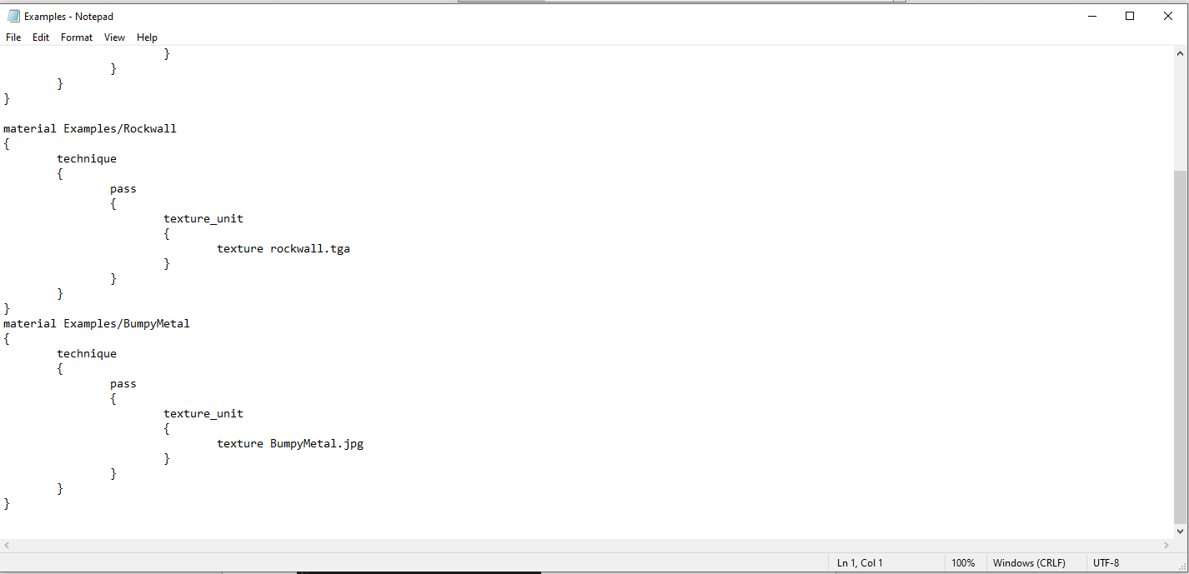

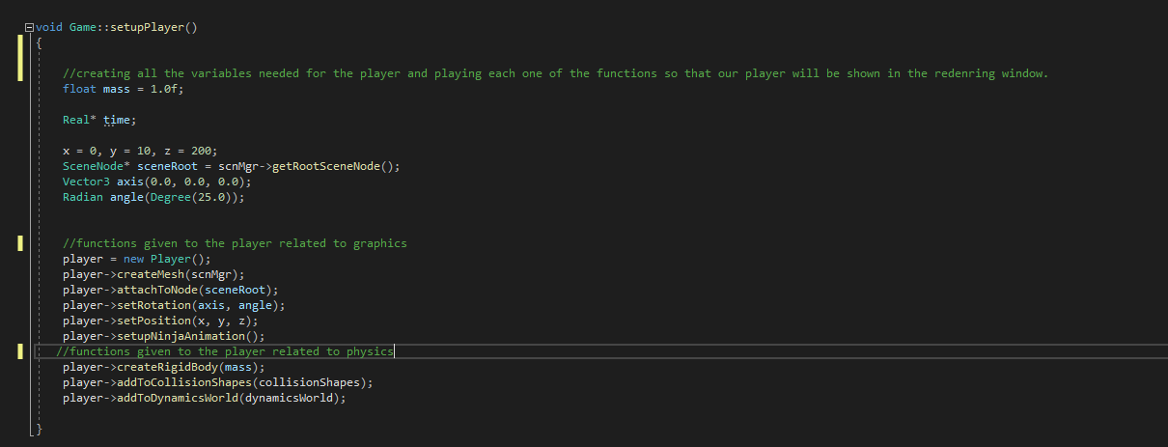

In this screenshot I am showing proof of making a function which is to setup the player. In this function is where we will organize everything that we made in the player.CPP to utilize in this function. As we can see in this function, we are creating a player which is going to be equal to the player class itself. This way we can access the functions that were created in the player class. As we can see in the screenshot, we have the function to create a mesh and attach node. In the previous screen shot we didn’t show the other functions but in this one we can see the there are other 3functions which are rotation, position, and animation. As their names say the rotation will change the rotation of the character depending on the number used on both the angle and axis. The position function will put my player into the position that you would like it to be on a specific XYZ axis. As we can see in this object, I also am using a function called setup ninja animation this will put our player object with a starting idle animation within our world. In addition, the reason in this code we create all the integers in the setup player function is because we only want them to exist for the first time and after that throughout the whole game, as later on we don’t actually need them anymore cause the functions are only played once in the game.

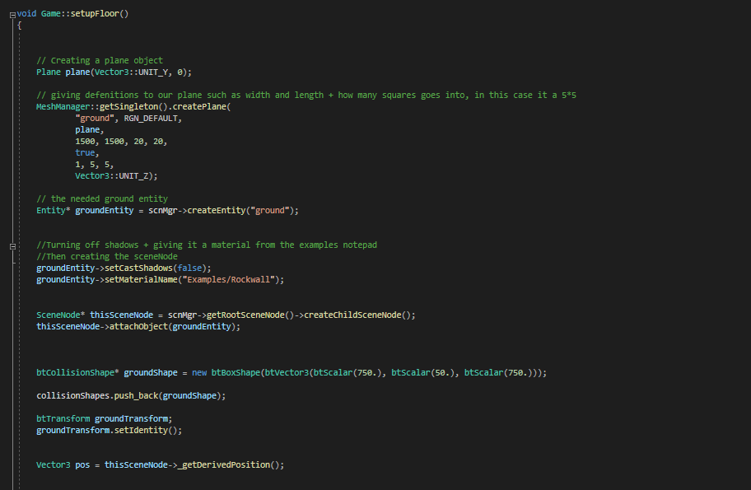

In this screenshot we are looking into the other way of making graphics in our game this is a more direct of making objects as we are using Ogres functions to make certain objects as the screenshot shows in this one, we are using the class plane to make a plane which is literally a square with no width to it. After creating it we need to assign values to is which are going to decide on how many squares are inside your plane or how big your plane will be. in this example of screenshot, we can see how there is another function used which is called setMaterialName() in this function what it does is that it will get a specific material that you have in your repository and it will apply it to the object that you have in your game in this case it was the plane.

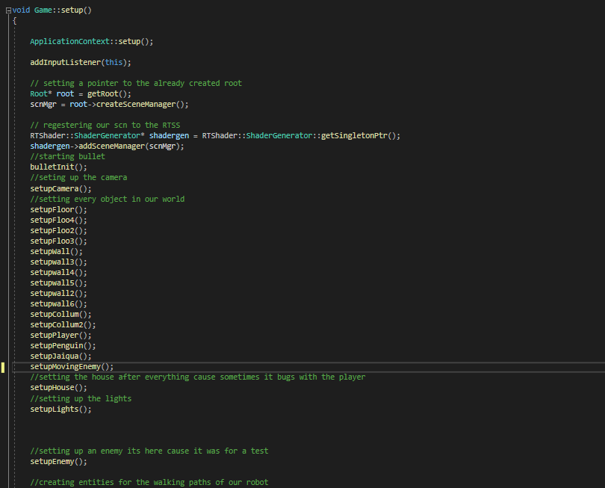

In this screenshot we can see all the different functions that I created so that each object that I have within my scene will then be run in the setup and be created in my game world. what the setup does is basically run call every function given to it once unlike the frame listeners the setup only runs once will the frame listeners will run multiple times and have a different objective than the setup. in the setup we can also see that its where we give the scene manager the Shader Generator.

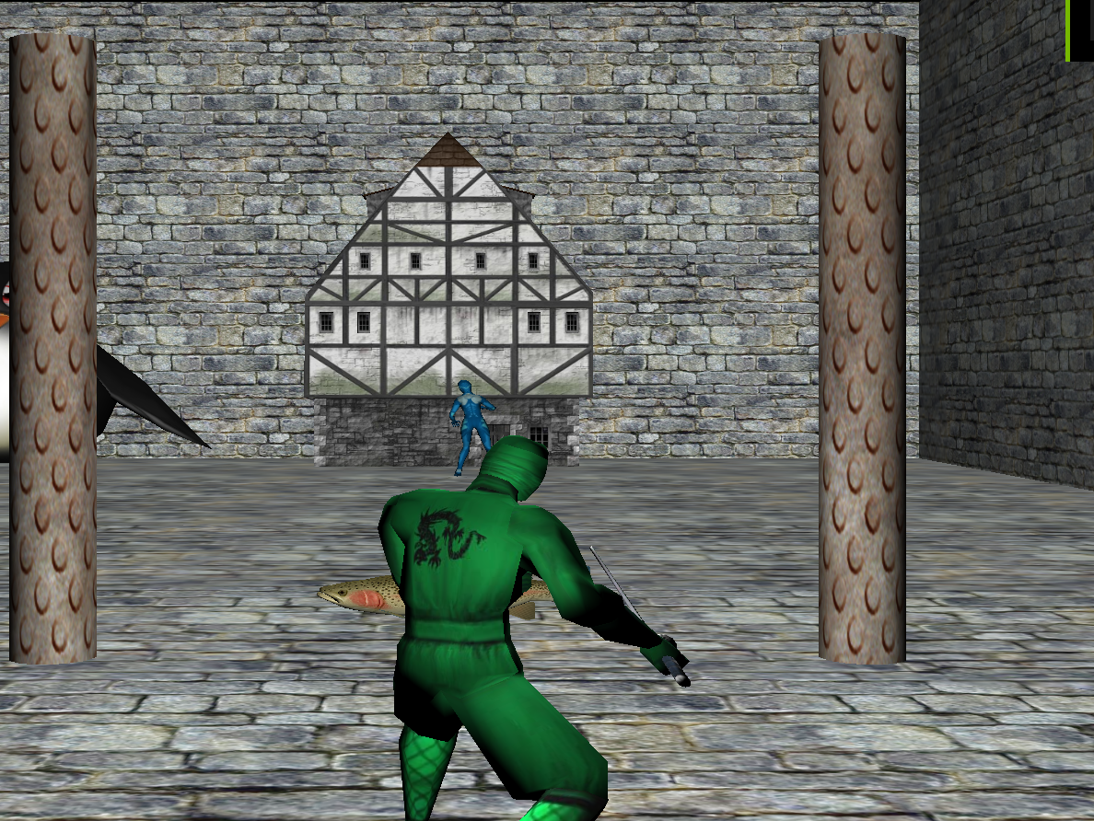

In this screenshot we can see all the objects that I added into my world with all their textures in as well, I decided to just make a mixed rocky world for this game as it felt that it would be more straightforward and work together without having to make multiple different tweaks to where their positions should be or having different images above each other so that it actually looks more better for a transaction in world style. In addition, in this example I also implemented a camera which it will move with the player when he moves into a certain direction, however the player sometimes moves faster than the camera so that camera needs tweaking so that they will be kept at the same position when moving. In addition, the camera doesn’t move with the player sideways so it's another functionality that needed to be added to the prototype of the game. A lot of the object that we see in the scenery are not moving and the reason is because they are setup to be dynamic objects, or they don’t have specific code in their physics to make them move. The fish for example since I set him higher up, we can see the fish falling down cause the gravity is being applied to it.

**Player Movement and controls:**

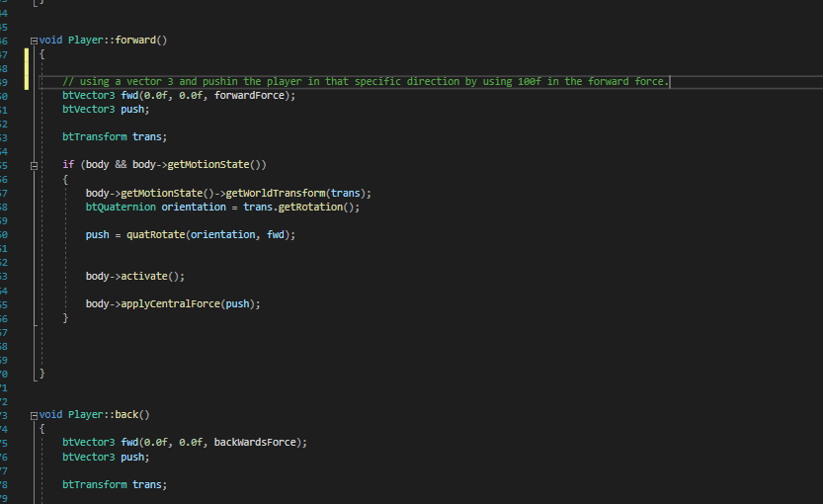

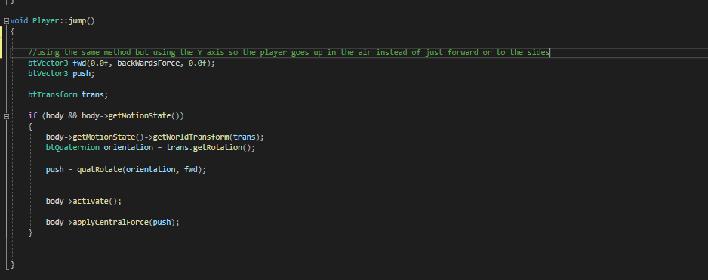

In my player the way that I am making him move is by using a pushing forward which it will apply force on the player using the physics used in bullet to make him move forward. In the screenshot the “force” has the number of 100f. And the way that it works since it is using a vector three it requires 3 axis which are x y and z depending on where you put the number in it will apply force towards that direction and it will also slowly decay unless we call another function that will make that force be zero and stop the player from moving. As you see in my Jumping function I put the force in the middle cause I want to make the player go up and not forward and that is the reason why in forward I use it in the 3rd slot of the function which is the Z axis.

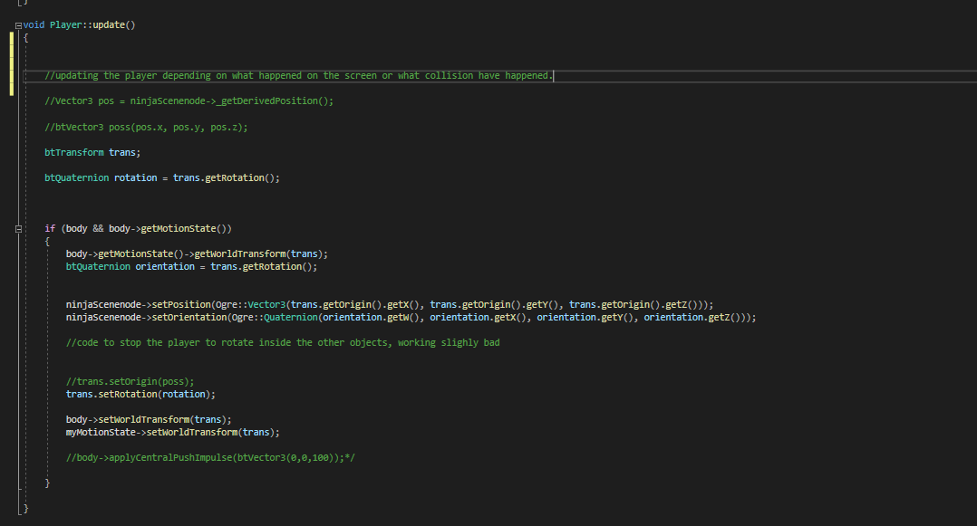

In addition to the movement since we are using physics for our player, we are going to need an update method so that every time some type of force is applied to it, we can update the position of the player which is done in this function called update() . The update function in the player is using the rigid body created in the player and a Quart ternion created by using the transform of the player which is from his current rotation.

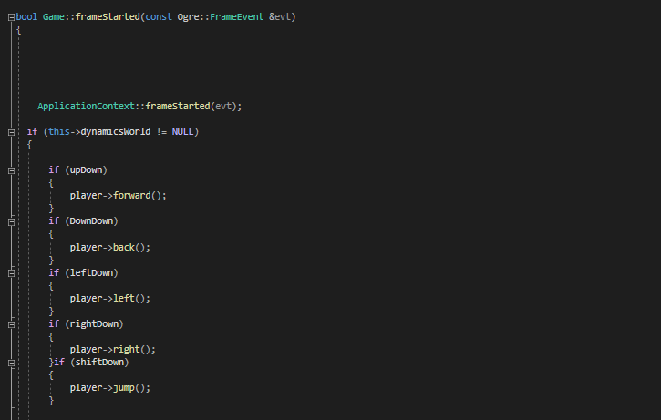

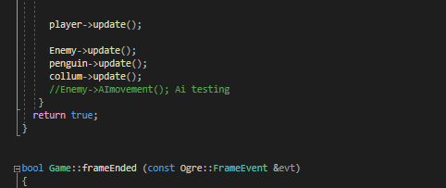

After creating all the functions that we need for our player to move forward we need to create more functions in our game so that the player is able to access them and move forward so what I have done is call the update from the player in a frame listener so that the player will always be updating depending on could be happening in the physics world. In this case the forward force being applied player. In addition to that we make a couple of if statements so that whenever to booleans that we created are true they will play the function we are giving to our player as an example if we press the Up key it's going to make the bool upDown to true which will then make the function forward play.

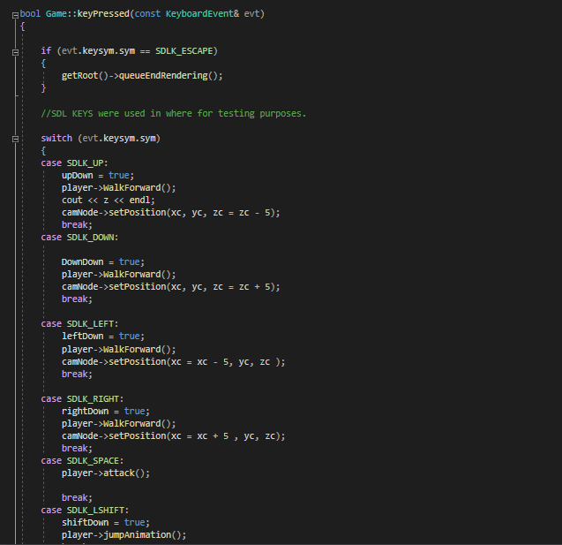

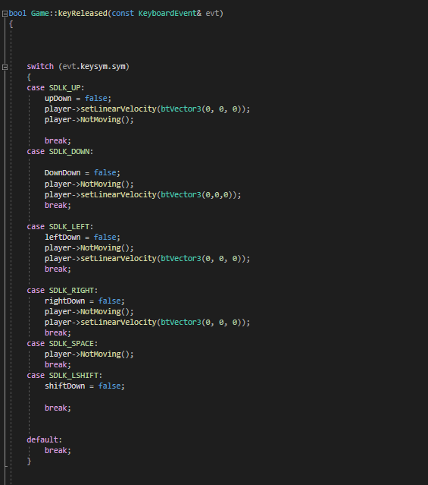

The way that we make sure that the player won't be stuck in one state is by using a function for when pressing the keys and another function for when not pressing the keys as you can see in the first screenshot, we see the code all in 1 switch case which depending on the key being pressed it will play that specific part of the case. In addition, it will make the right movement for the player true. When the key is released it will stop playing that code and, in the key released, we have another function called NotMoving(), which what it does its set all forces applied to the player be 0 meaning he will just stop suddenly this could have had some more work and had a decreasing factor to it.

**Player collision within the world:**

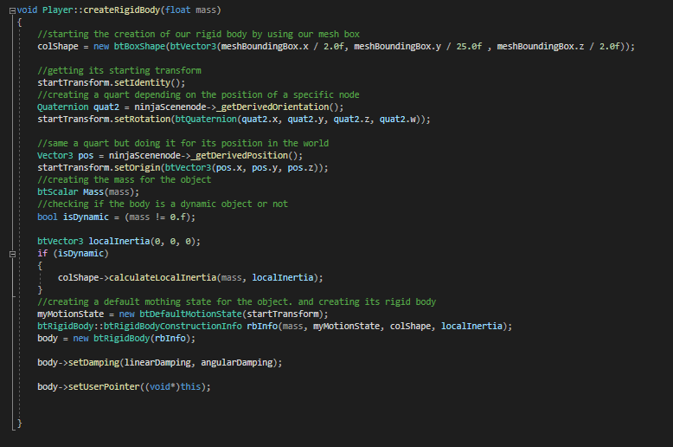

In this screenshot we can see the variables that an object takes for us to be able to create a rigid body which are of a collision shape, quaternion for rotation of the object a vector 3 for the position of the object and then we need to also have mass to know how heavy our object is within the world and how quickly they will fall. After creating all these variables, we are going to use them to make a rigid body and set the pointer to “this” object. In addition, depending on the about of mass given to our object it can either became a dynamic object or not. A dynamic object is basically an object within the world that isn't able to move but it also won't be pushed away by other objects within the dynamic's world.

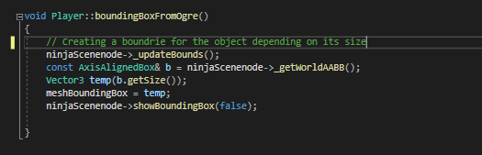

In addition, we need to make a bounding box so that we know the limits of the objects and how close the player can go to a certain object. There is a function used in here which is _updatebounds() and what it does is depending on the position or orientation of the object it will update the box assigned to the object.

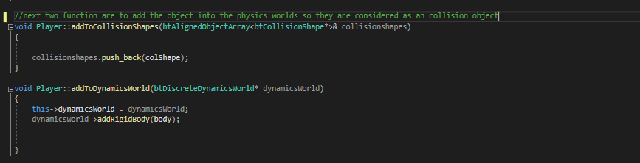

To give physics to our player we are going to need to add them to the dynamics and collision shapes world and what these functions do is store the different shapes and identify them so that they are able to collide against each other and no just go through them.

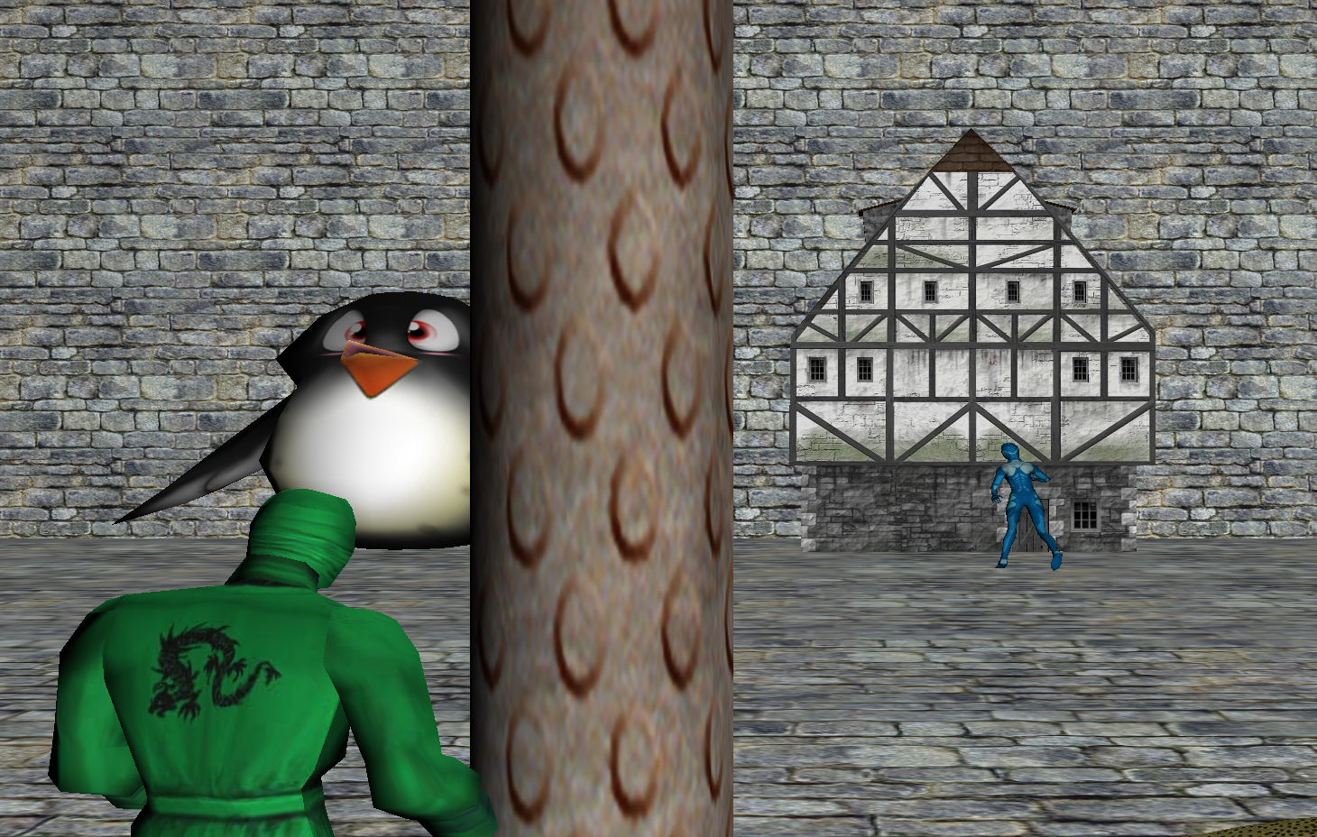

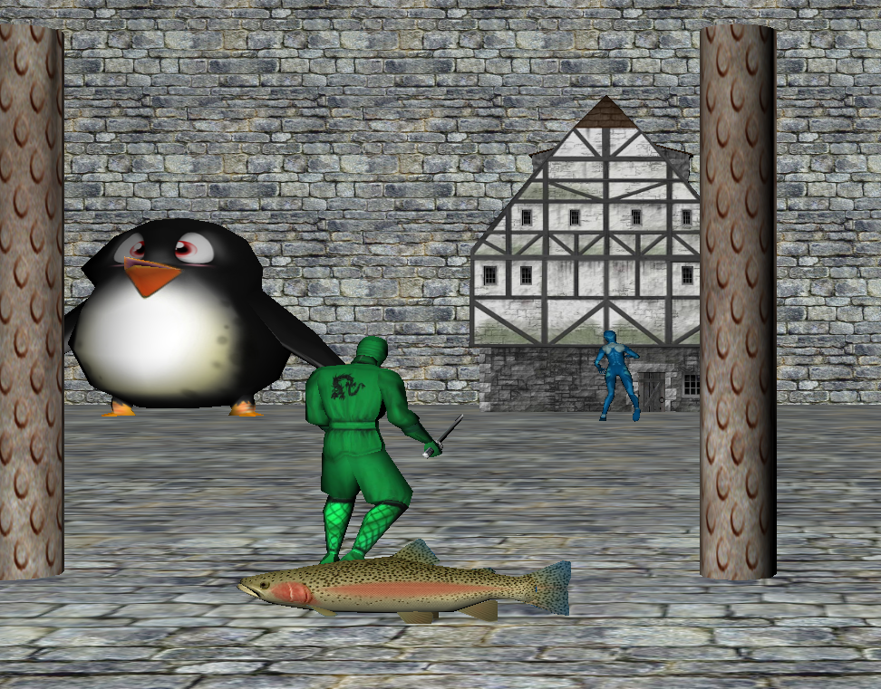

In the first screenshot, we have the player colliding with a pilar as we can see the camera is moved more to the right due to the player no being able to go through the pillar as the pilar is set up to be a dynamic object within the world which means that the player collides with it, doesn’t go through it and it will have to move through another direction to me able to move. However, in the second image we can see the player colliding with a fish and since the fish isn't a dynamic object the player is able to push the fish away even if slowly the player can push this fish away. The same thing can happen with the penguin in the picture however due to its size its harder for the player to knock down the or push it.

**Enemy AI**

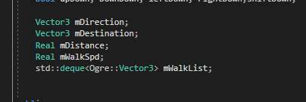

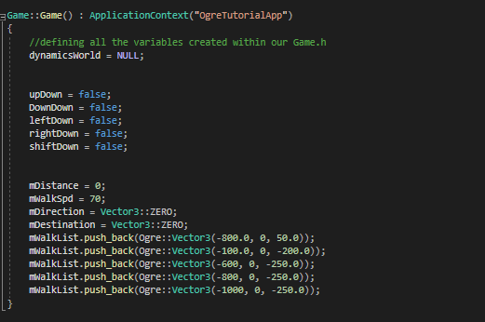

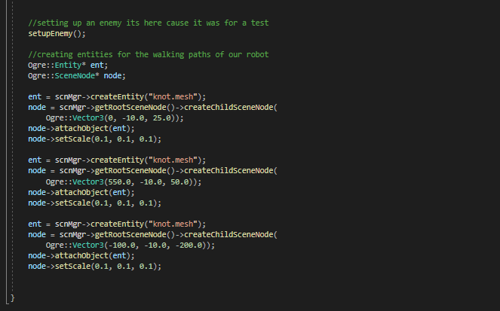

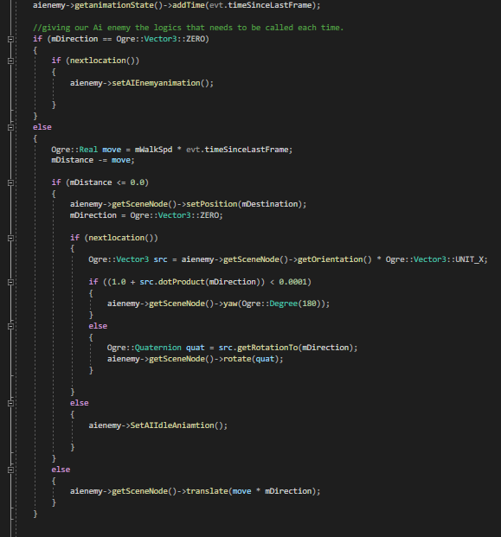

For my enemy I made a simple ai which it will follow a specific path that will have been given to him to do this we start by creating different variables like speed and direction and a list which will store the different positions of where we want our ai enemy to go to. After defining all the variable and creating the needed nodes we need to implement some code within our frame started function because we want to be able to call it multiple times and give it information on what to do when it reaches a certain position in the map.

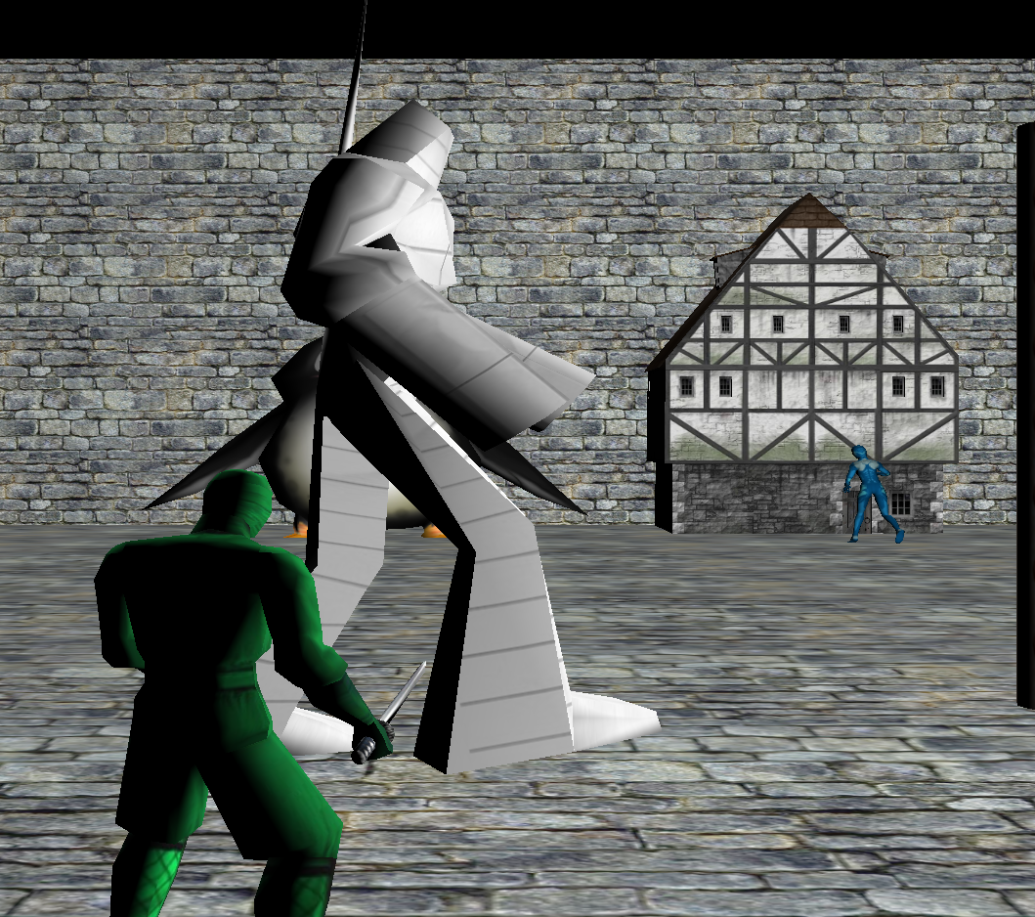

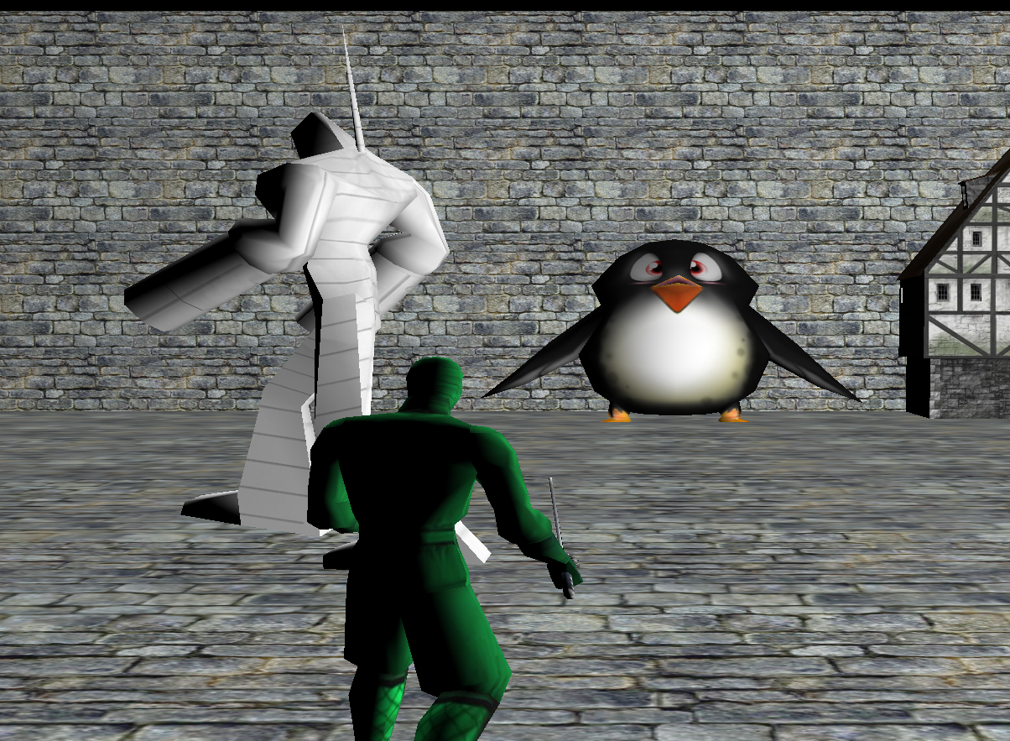

As we can see in these Two screenshots, we can see the Robot ai walking in one way as their way point in in a direction and then on the second one, we have him walking back with the correct rotation cause in the statements we define it so that the robot also turns when it has to go a certain direction.

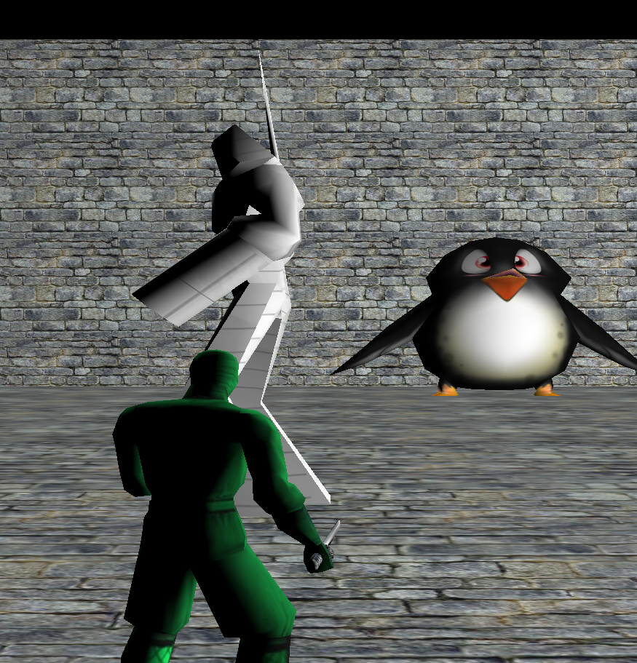

In this screenshot it's to show that once the robot has gone all of its way points it will go into an idle animation and the reason it does it because at the end of the statement we tell him if there are no more way points “do this animation”. The reason why is because since it doesn’t have any more waypoints it won't move anymore.

**Conclusion**

In conclusion, if I were to do this assignment again there would have been certain code factors that I would have changed as an example I would have changed the coding for the camera as it sometimes still bugs and there is no rotation to the camera. In addition, I would also have extra movement to the players movement so that the player would be able to rotate in the map with the camera as well and not just only be able to move in 4 directions. I would also have improved into the enemy AI and try adding some kind of collision between the player and the robot so that when they bump into each other one of them takes damage. I would also improve in the organization of the code as there are a lot of things in the setup of our code that could be put into a separate coding file. I would try adding more mechanics than just physics and graphics for example I would audio into the game to try and at least give it walking audio. I would also improve on the layout of the level because as the level stands it is just a basic box square with a lot of figures around the map.

**UML Diagrams**

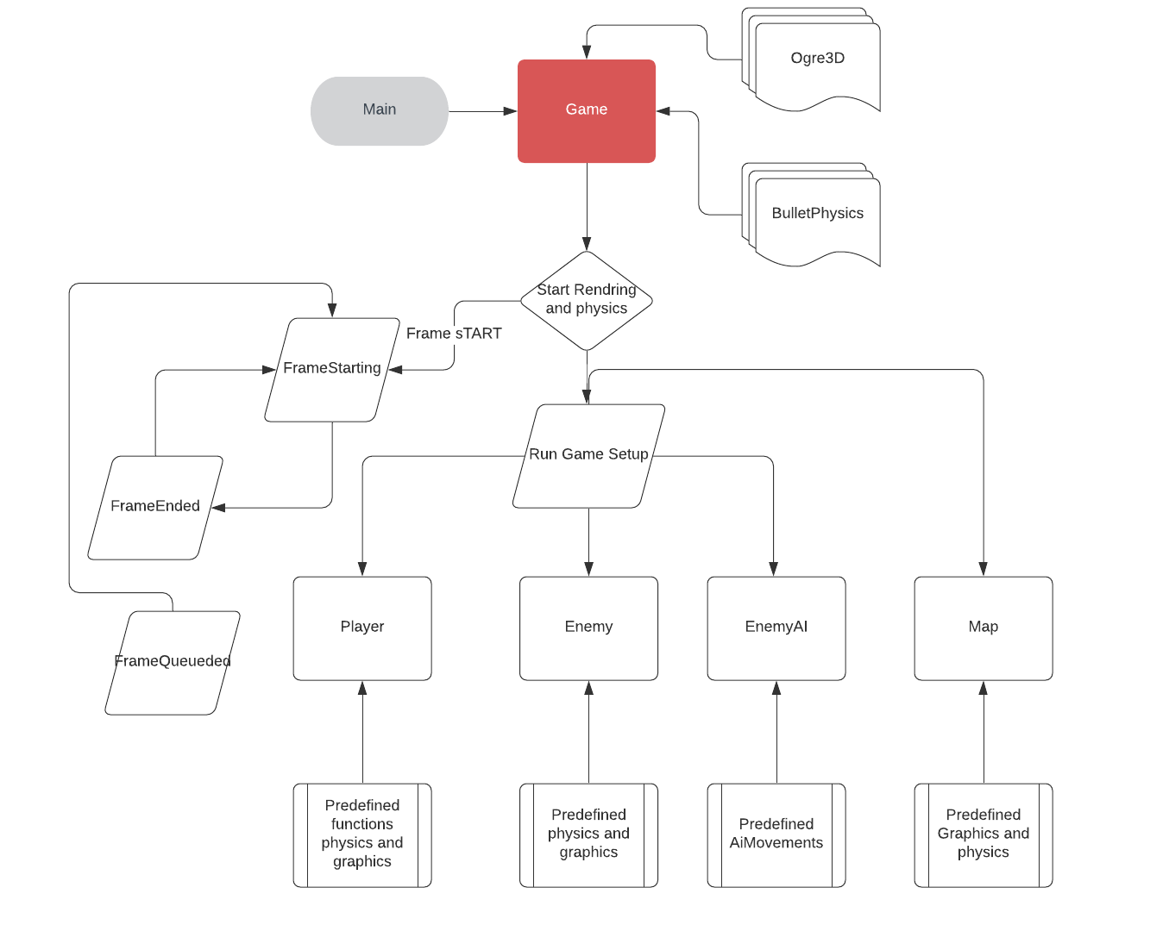

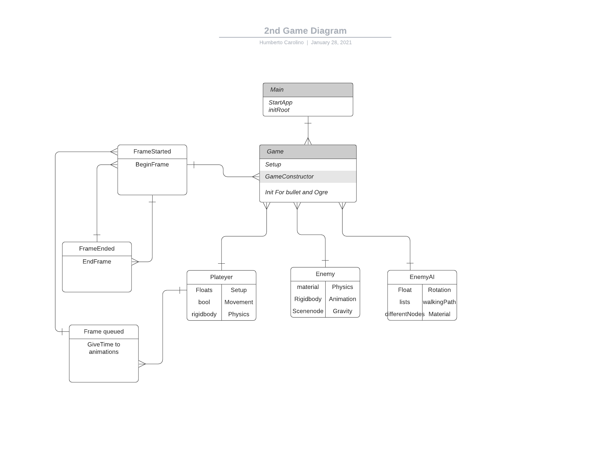

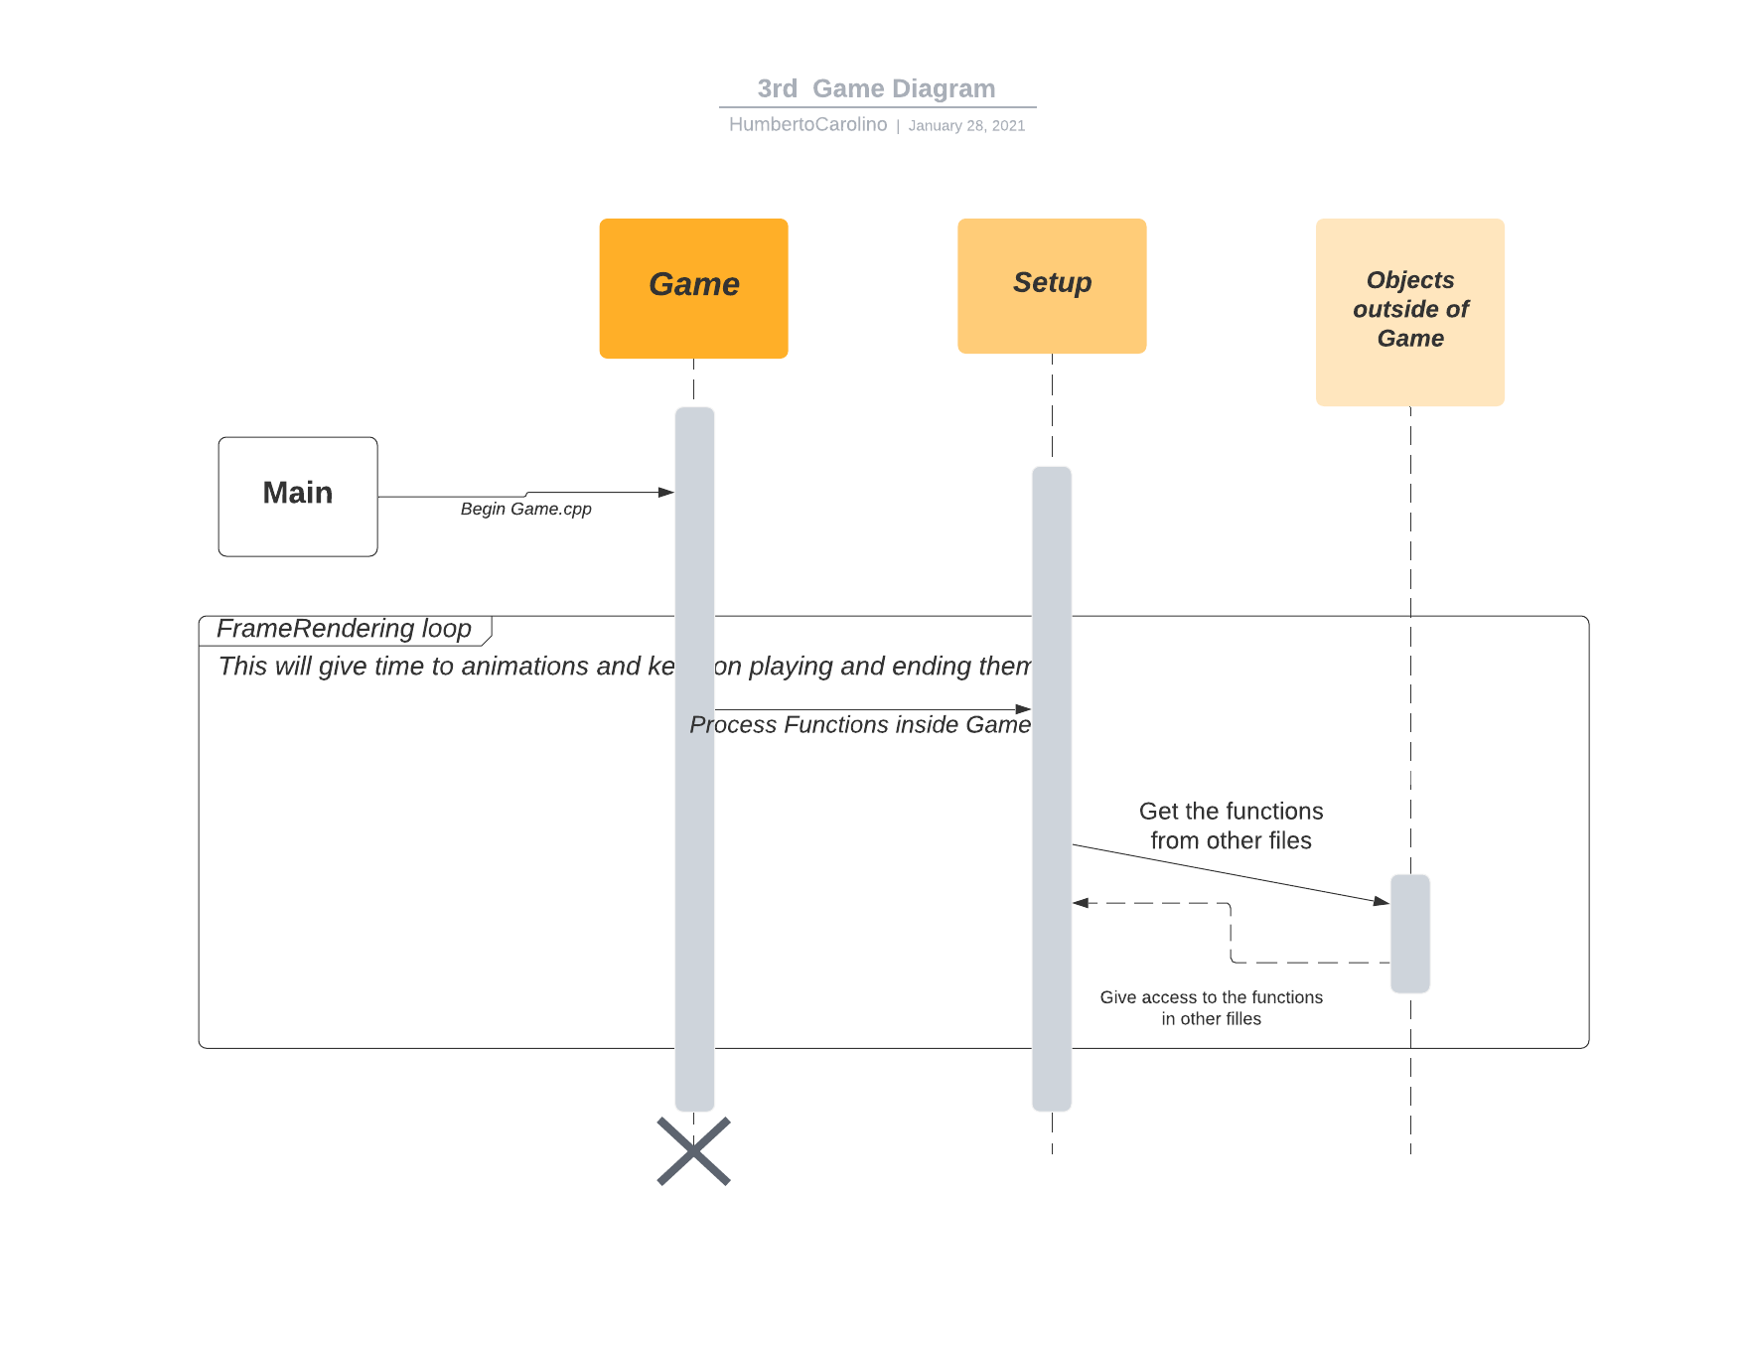

## References

CardiffMetrapolitan (n.d.). [*https://metsearch.cardiffmet.ac.uk/primo-explore/fulldisplay?docid=44CMU_ALMA5176532650002425&context=L&vid=44WHELF_CMU_NUI1&lang=en_US&search_scope=CSCOP_EVERYTHING&adaptor=Local%2520Search%2520Engine&isFrbr=true&tab=tab1&query=any*](https://metsearch.cardiffmet.ac.uk/primo-explore/fulldisplay?docid=44CMU_ALMA5176532650002425&context=L&vid=44WHELF_CMU_NUI1&lang=en_US&search_scope=CSCOP_EVERYTHING&adaptor=Local%2520Search%2520Engine&isFrbr=true&tab=tab1&query=any). [online] metsearch.cardiffmet.ac.uk. Available at: <https://metsearch.cardiffmet.ac.uk/primo-explore/fulldisplay?docid=44CMU_ALMA5176532650002425&context=L&vid=44WHELF_CMU_NUI1&lang=en_US&search_scope=CSCOP_EVERYTHING&adaptor=Local%20Search%20Engine&isFrbr=true&tab=tab1&query=any> [Accessed 28 Jan. 2021]. Another Ogre Book.

CardiffMetrapolitan (n.d.). [*https://metsearch.cardiffmet.ac.uk/primo-explore/fulldisplay?docid=44CMU_ALMA5176532920002425&context=L&vid=44WHELF_CMU_NUI1&lang=en_US&search_scope=CSCOP_EVERYTHING&adaptor=Local%2520Search%2520Engine&isFrbr=true&tab=tab1&query=any*](https://metsearch.cardiffmet.ac.uk/primo-explore/fulldisplay?docid=44CMU_ALMA5176532920002425&context=L&vid=44WHELF_CMU_NUI1&lang=en_US&search_scope=CSCOP_EVERYTHING&adaptor=Local%2520Search%2520Engine&isFrbr=true&tab=tab1&query=any). [online] metsearch.cardiffmet.ac.uk. Available at: <https://metsearch.cardiffmet.ac.uk/primo-explore/fulldisplay?docid=44CMU_ALMA5176532920002425&context=L&vid=44WHELF_CMU_NUI1&lang=en_US&search_scope=CSCOP_EVERYTHING&adaptor=Local%20Search%20Engine&isFrbr=true&tab=tab1&query=any> [Accessed 28 Jan. 2021]. Book into the basics of ogre.

Ogre3d (n.d.). *OGRE: API Reference Start Page*. [online] ogrecave.github.io. Available at: <https://ogrecave.github.io/ogre/api/latest/> [Accessed 28 Jan. 2021]. Ogres Official Website.